## CIN:U73100MH2019PTC326522



CERTIFICATE OF INTERNSHIP

# This is to certify that

**Om Purohit**

# has successfully completed his internship at

**Twimbit (R&D Division)** from **August 01,2020** till **May 1, 2021** as a

**Data Science Intern**

He has worked proficiently and sincerely on plethora of projects such as:

1. NLP Dashboard with Dash Plotly
2. Implemented Topic clustering, Semantic search and Summarization
3. Time-series forecasting
4. Scraping Dynamic websites
5. Graph Database creation and management using Neo4j
6. Creating and managing chrome extensions
7. Visualisations using D3.js

I personally thank him for his work and ensure anyone to have him for his exceptional talent and will power.

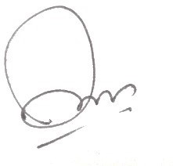

**Aman Sharma** Place : **Noida**

CTO Twimbit Date : **29 April 2021**

Twimbit Research India Pvt. Ltd.

Twimbit, Nukleus Co-working,

I.T. Tower, Plot 29, Sector 142, Noida

## [reachus@twimbit.com](mailto:reachus@twimbit.com) twimbit.com